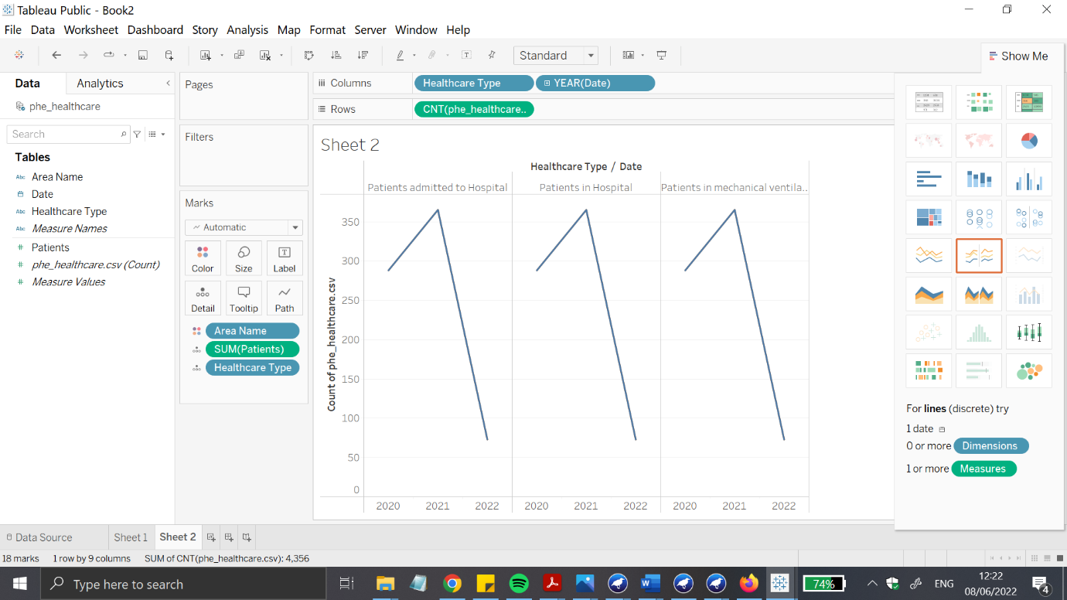

Figure Count of health care count in the UK

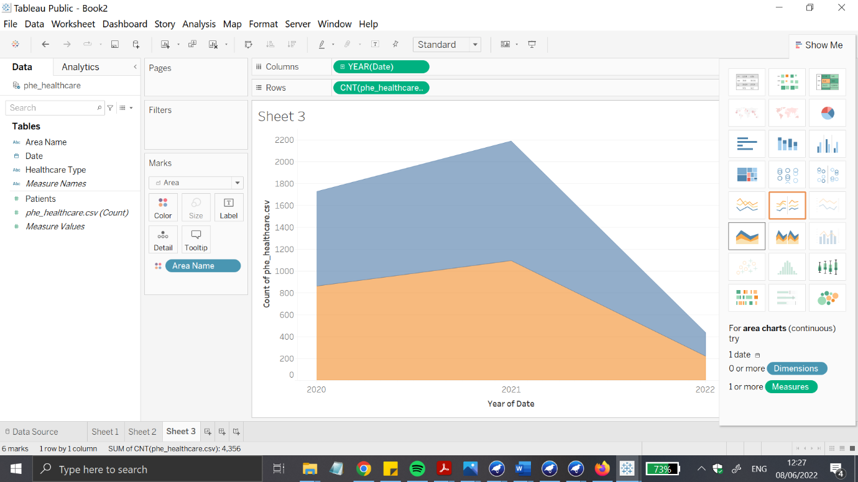Figure Line graph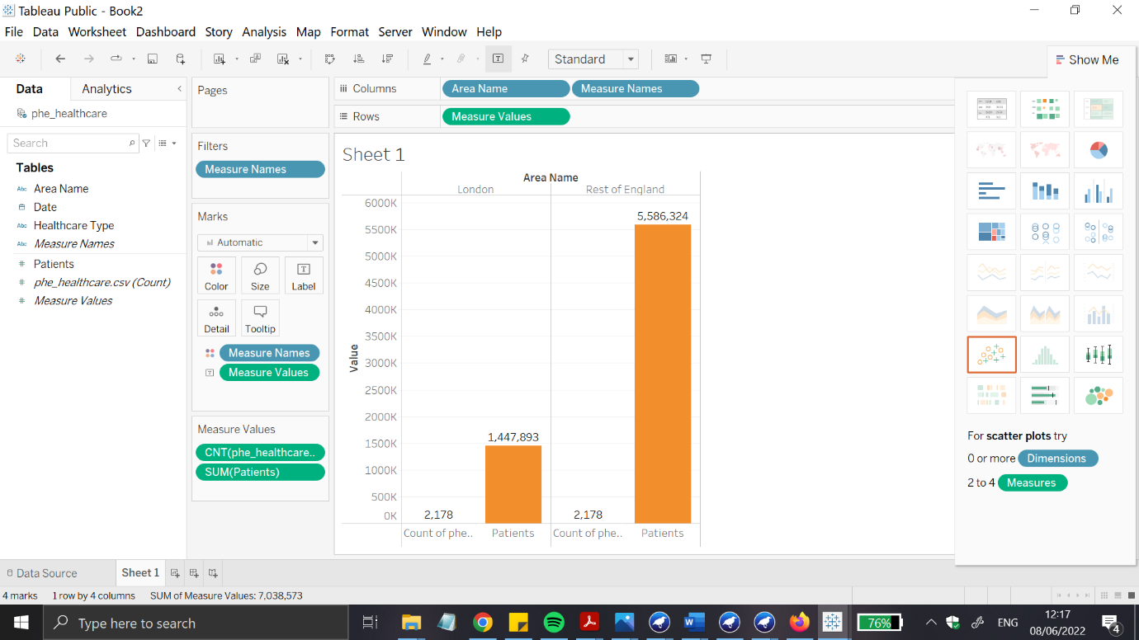Figure Patient counts throughout in the UK

|  |  |  |  |  |  |
| --- | --- | --- | --- | --- | --- |
| Sr number | J48 cross validation 10 folds | NaIveBayes, cross validation 10 folds | ZeroR cross validation, cross validation 10 folds | IBK cross validation, 10 folds | PART cross validation 10 folds |
| 1) | 82.9721% | 84.2109% | 75.5418% | 82.3529% | 82.9721% |
| 2) | 85.4498% | 84.2109% | 75.5418% | 80.1858% | 83.9009% |
| 3) | 85.1393% | 84.5201% | 75.5418% | 82.3529% | 84.8297% |
| 4) | 84.8297% | 85.1393% | 75.5418% | 81.1146% | 84.2105% |
| 5) | 85.4489% | 83.9009% | 75.5418% | 80.4954% | 82.6625% |
| 6) | 85.4489% | 84.5201% | 75.5418% | 80.4954% | 85.1393% |
| 7) | 85.4489% | 83.5913% | 75.5418% | 82.0422% | 84.8217% |
| 8) | 86.0681% | 83.5913% | 75.5418% | 80.4954% | 85.1393% |
| 9) | 84.8297% | 84.8297% | 75.5418% | 81.4241% | 84.5201% |
| 10) | 86.0681% | 83.5913% | 75.5418% | 80.4954% | 83.2817% |

Literature review :-

New kinds of studies have been performed on records mining strategies in clinical databases. the number one descriptions are identified:  
1. research and demanding situations in mining scientific facts in general are summarised in studies.  
2. research on the usage of DM techniques within the evaluation and/or prognosis of sure illnesses  
three. studies into elements which is probably associated with a higher occurrence of infection danger.  
4. studies into growing enhancements and techniques.  
five. research on novel frameworks, device, and packages in medication and healthcare.

The following are the investigations inside the first magnificence: R. D. Canlas Jr [6] researches advanced analytics and problems in healthcare. A survey of records mining tool studying methodologies and scientific diagnostic structures is provided with the aid of N.Satyanandam et al.[24]. F.Hosseinkhah et al.[25] talk the difficulties of mining scientific databases for records. They focus on the residences of scientific statistics and present a few bodily phenomena using information mining strategies which incorporates Nave Bayes, Neural Networks, and affiliation guidelines on a gastrointestinal scientific database. S. ok. Wasan, V. Bhatnagar, and H. Kaur [32] investigate the have an effect on of records mining techniques on scientific diagnoses, which include artificial neural networks. They point out a few areas in medical wherein facts mining and information can be used to reap knowledge from healthcare databases.

for individual to discover which records mining technique is particularly used for disorder prognosis and which for disorder analysis, the studies inside the magnificence may be in addition divided into three categories: people who use machine reading strategies for disorder analysis, illnesses evaluation, or every scientific prognosis.as a way to choose out which records mining approach is specifically used for ailment diagnosis and which for sickness analysis, the studies within the category can be in addition divided into 3 classes: individuals who use system learning strategies for disorder prognosis, illnesses prognosis, or both scientific evaluation.